**Fast Fashion Is Demolishing Sustainability; We Need Something New**

Vikrant Sabharwal

“Silky cotton split-neck sweater, only $12!” “Beautiful dresses, at your doorstep in hours!” These are the fast fashion ads that are all over social media. The fast fashion industry has fundamentally altered our shopping habits. Whether we’re clicking on ads on social media or scrambling for the latest clothes online, the industry has led us to view clothes by how much they match the latest trend, rather than their quality. We view them as temporary rather than durable commodities. Fast fashion has caused us to forget where our clothes come from. It has given us the false impression that we are doing the right thing by saving money, when in actuality we are stimulating a series of unethical practices. These irresistible deals wreak havoc on the lives of the workers and the environment.

Fast fashion was first used to describe clothing brand Zara’s mission to take a garment from the design stage to the stores in 15 days. The clothing was cheap and still high quality, too good to miss out on. Today, fast fashion businesses sell low-quality clothing at ultra-cheap prices. We have reached a point where consumers can see new fast fashion trends on social media and press a button to order the clothing, 15 minutes after they were modeled on the runway. Through fast fashion’s prominence on social media, it has become a magnet for the younger generation. One in three young women consider garments worn once or twice to be old. While the monetary cost of the clothes might be low, the human misery and environmental cost is off the charts.

Scrolling through Instagram reveals a flood of ads for trendy and cheap clothes. I never thought much about these ads until I came across a case study about fast fashion factories in Indonesia. These factories dump hoards of raw materials and runoff into the Citarum river, killing its wildlife. The factories pollute the air, killing tens of thousands of people. Anytime that I see an ad for fast fashion, images of this devastation fill my head.

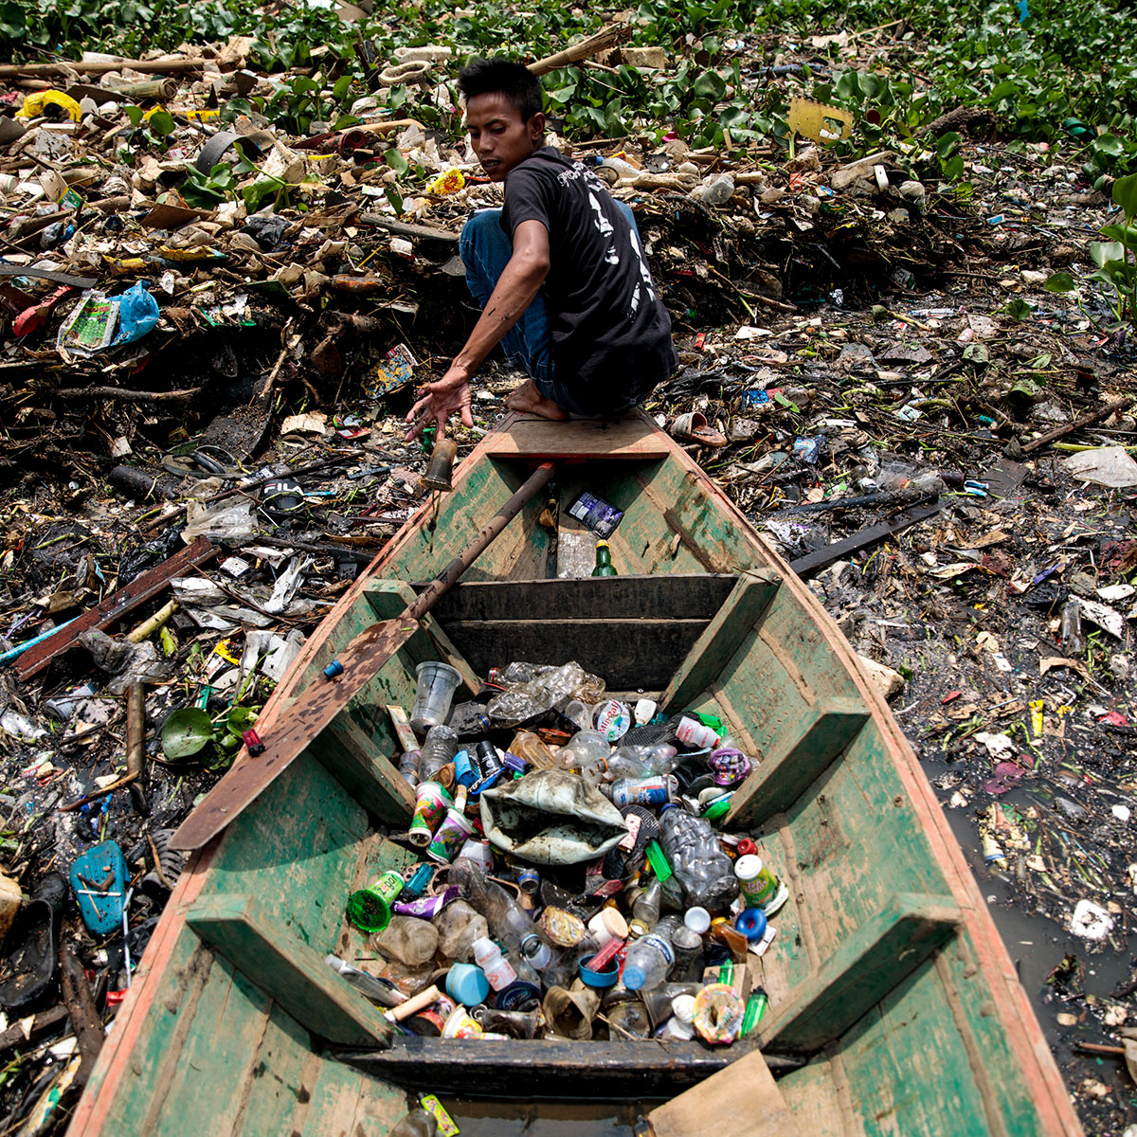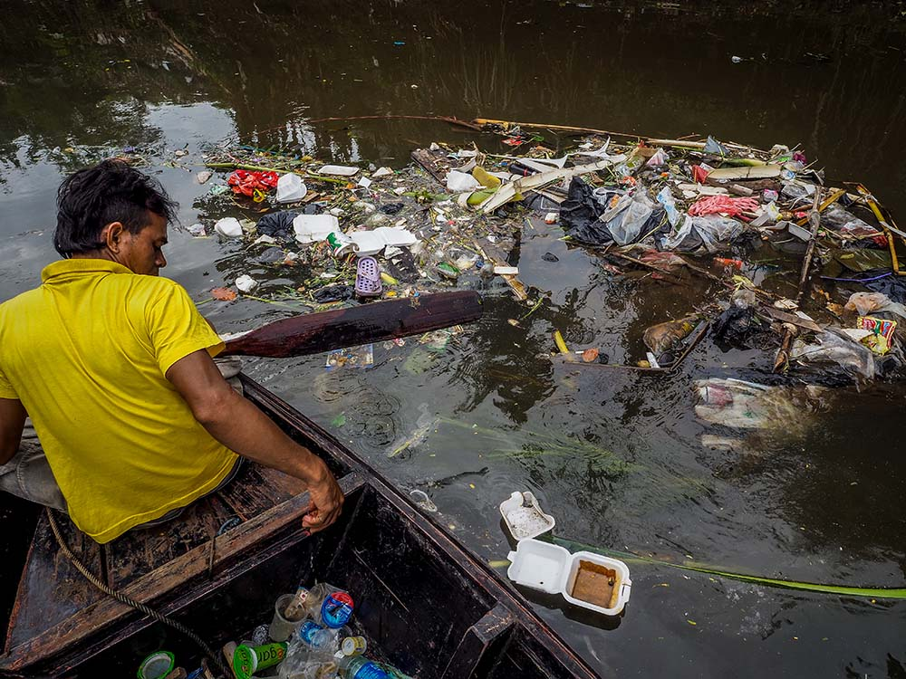

The effects of the Indonesian fast fashion factory on the Citarum river.

By buying fast fashion clothing, such as a pair of $12 graffiti jeans, we are enabling the exploitation of millions of workers around the world. 93% of fast fashion companies aren’t paying liveable wages. Boohoo is a major company which undercompensated their employees. In their Leicester factory, they paid workers $4.40. During the COVID-19 pandemic, they provided similarly low levels of compensation while their employees simultaneously put their lives at risk and tried to swim out of their devastating economic troubles. Their Los Angeles factory is paying sewists $2.77 per hour. Their justification prioritizes corporate interests over human welfare, as they claim that this is needed for them to compete with brands from overseas who pay their workers even less. Since 2016, Fashion Nova owes $3.8 million in back wages, while their earnings reached nearly a billion dollars in 2019.

The wages these companies pay keep workers stuck in a cycle of poverty. While the owners of these businesses count their wealth, their employees are left with little money for food, electricity, and other basic necessities. Many go homeless entirely, losing their home to evictions. They may be able to obtain primary and secondary education for their children through public school but have no way of affording college tuition. Without adequate resources, it is extremely difficult for these workers to provide for children, and they are excluded from any form of sustainable development.

Even worse, fast fashion pollutes the environment and contribute to climate change at each stage of the supply chain. The fast fashion industry emits 8% of total carbon dioxide emissions on the planet. Forever 21 is one of the biggest polluters in the industry. Their main sources of pollution are producing new clothing and disposing of thousands of unsold clothes as waste every day. This waste accumulates rapidly in landfills, which release hundreds of millions of metric tons of carbon dioxide. In addition this waste has a massive effect on biodiversity in ecosystems surrounding these landfills. It reduces the complexity and therefore the resilience of ecosystems, which makes them more vulnerable to future disturbances.

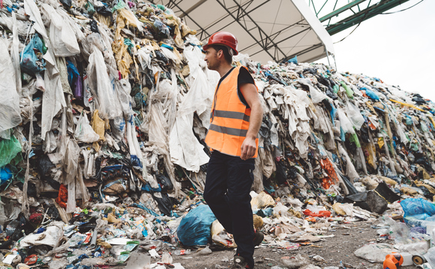

The devastating impacts of fast fashion are haunting both workers and the environment.

Another clothing company, Urban Outfitters, is contributing in a huge proportion to the depletion of water resources around the world. They use toxic materials in the construction of clothes. A staggering 20% of industrial water pollution comes from these processes, and they also put millions of people into water scarcity around the world.. The impacts of water scarcity quickly spill over to cause other major problems such as food shortages, as there is not enough water to grow crops effectively. While Urban Outfitters might just be one company, but their actions are having a massive global impact.

Instead of supporting businesses which keep people hungry and homeless, we must shop with sustainable fashion companies who go beyond the minimum requirements to produce their clothes. The fashion industry has historically been notorious for undercompensating their workers, but companies like Patagonia and Raven + Lilly are fundamentally changing that trend. Unlike Boohoo, Patagonia champions a livable wage as a basic human right and are a founding member of the Fair Labor Association (FLA). Paying higher wages does not stop them from employing large numbers of people. (Salpini) Raven + Lily make sure that their artisans, the most exploited workers in the industry, are payed wages which meet the rigor and demand of their job. In addition, their company is led by women only and they have taken the lead in the industry in creating opportunities for women. (“Our Commitments”) Both companies have allowed workers the opportunity for social advancement. By progressing the effort on livable wages, they are advancing sustainable development by contributing majorly to an effort to allow workers to support themselves and their future generations.

Our dollars can support companies that advance environmental sustainability. The processes of manufacturing in fast fashion accounts for one-fifth of industrial water pollution. They use open-loop cycles where the waste is not cleaned and is instead directed onto waters or lands. Consumers can avoid this by shopping at Levi’s. Levi’s uses a waterless process which reduces water usage in denim fishing by up to 96%. (“Water < Less”) They saved more than 3 billion liters of water and recycled 1.5 billion liters of water through this process. (Segran) Through their actions, Levi’s is championing a cause that many fast fashion companies forget is a problem.

People Tree puts the environment at the forefront of their mission. They use a high proportion of eco-friendly materials which minimize the emissions from their waste (“Our Environmental Policy”). Unlike the vast majority of fashion companies, they are invested into the activities on their farm. They are one of the largest promoters of organic farming, using organic cotton only. This emits 94% less emissions than standard cotton. (“Ethical Analysis of People Tree”). Both of these companies are manifesting the fast fashion of the future.

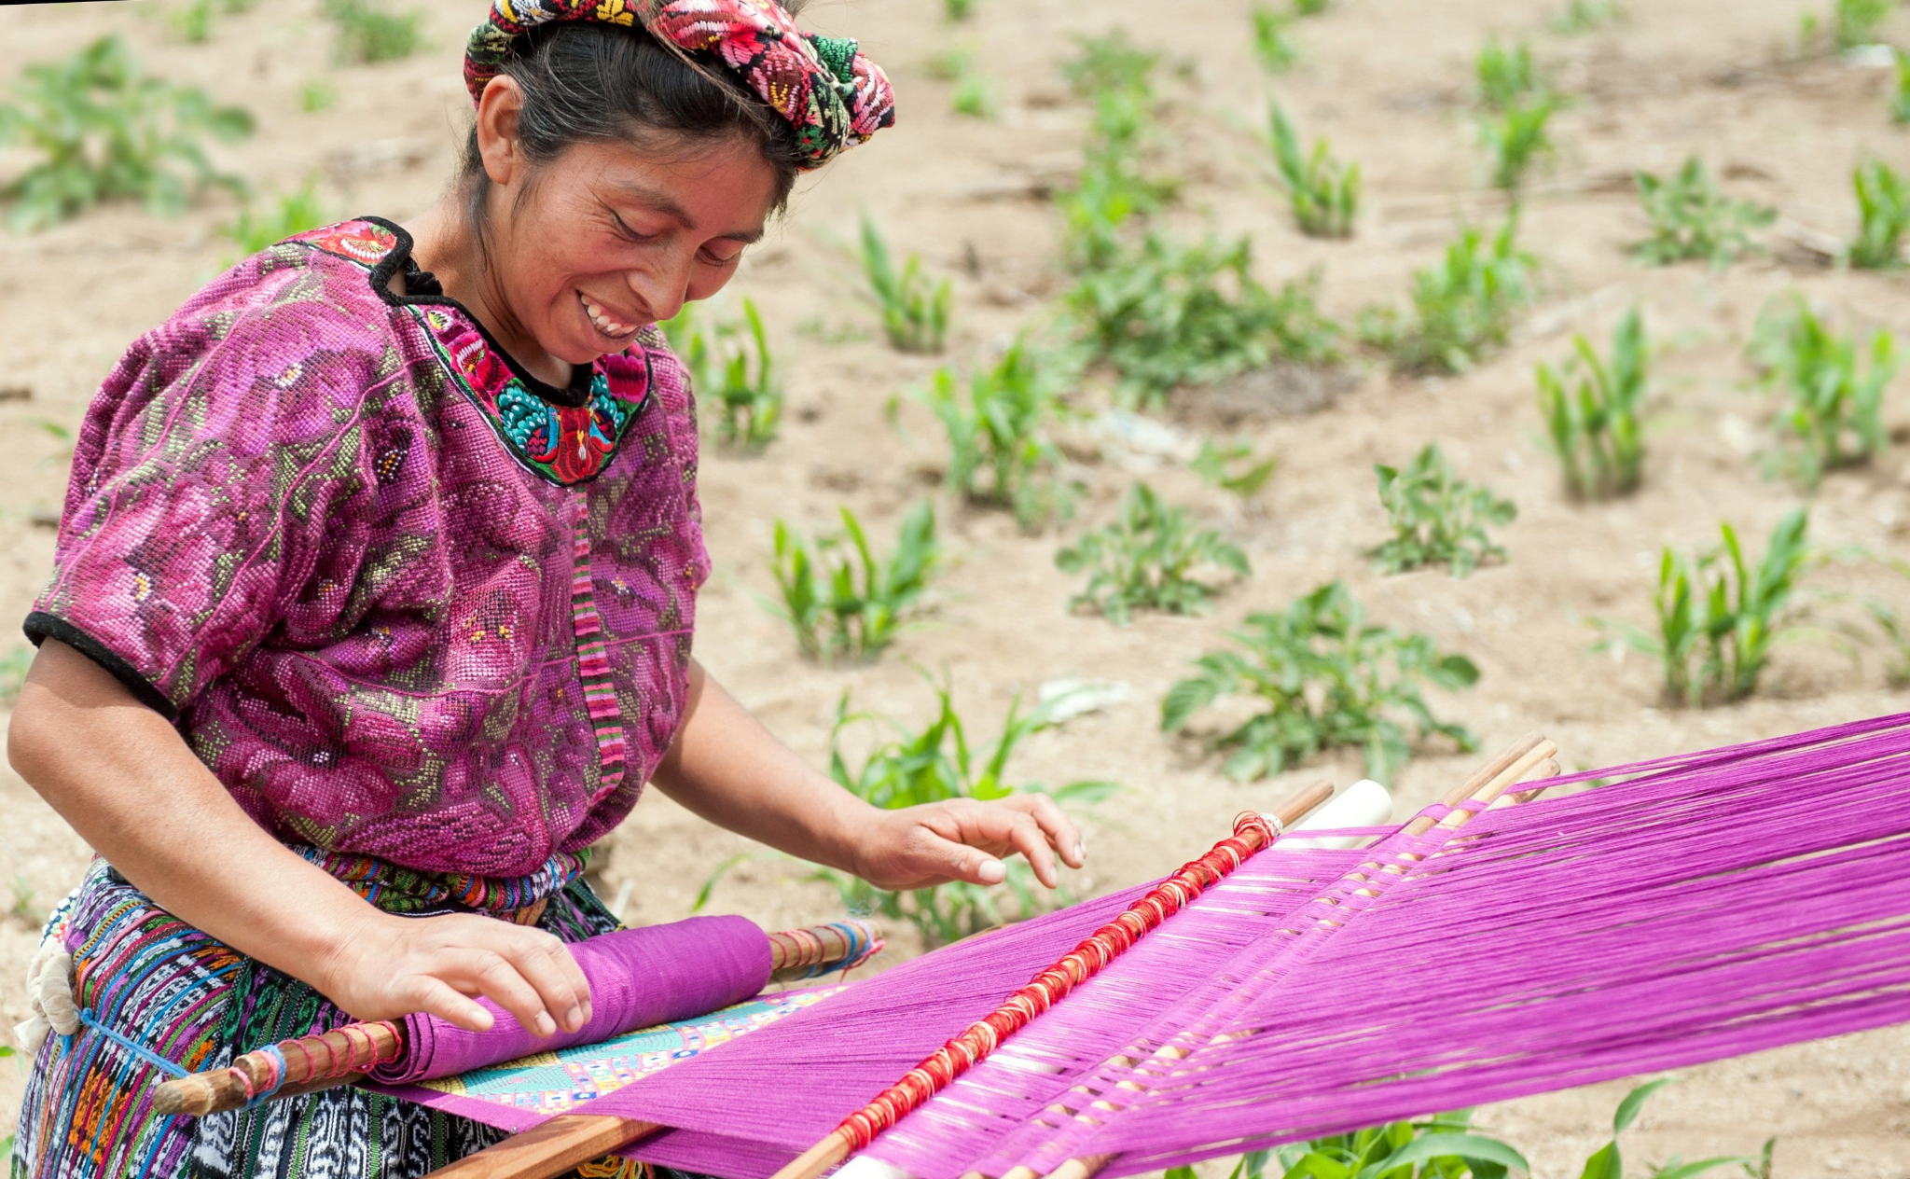

Sustainable fashion companies are prioritizing care for their employees and the environment when producing their clothes.

So what should we as consumers do to push for this kind of sustainable future? Our values can dictate our clothing choices, we need to rethink what we prioritize. If we begin to feel bored of our clothes, we must remember that discarding them contributes 44 pounds of CO2, equivalent to a passenger car driving 50 miles. (Guang) We have to consider what is more important in this equation: novelty or the death of the environment. Once the clothes are truly no longer of use to us, maybe they do not fit anymore or have lost their shape through wear and tear, we still should not dispose of them. We can effectively recycle our clothing. A fun way to do this would be through a clothing swap, where we can gather with friends or family, and exchange the our clothes for other items that we want from someone else. If this is not possible, especially given COVID-19, we can donate the jeans to local textile recycling programs. If we want to take it to the next level, we can compost the jeans in our garden and allow them to decompose since many natural fabrics are compostable. This would provide nutrients to allow for the growth of the plants in the garden. If we as consumers do not act, the impacts of fast-fashion will only worsen significantly. Before you click on the next ad for cheap clothing that you see, remember the millions of people and species who are innocently dying from your purchase.